Real-Time Monitoring and Resource Allocation in Public Administration: A Comprehensive Review

Hazeera B
Computer Science Engineering
Chennai Institute of Technology
Chennai, Tamil Nadu, India
hazeerab.cse2023@citchennai.net

Abstract - A dynamic data-driven framework to improve public administration's efficiency in certificate issuance is covered in this paper. Delays and growing backlogs result from traditional resource allocation models' frequent inability to modify their demands in response to shifting demand. The suggested framework supports improved resource utilization with the least amount of delay for delivery services by combining the advantages of cloud computing, real-time monitoring, and predictive analytics to react to variations in demand. These will enable more proactive resource management through AI-driven demand forecasting, regular adjustments, and real-time dashboards. The results show significant gains in speed, transparency, and citizen satisfaction when handling the practical difficulties of data standardization and system interoperability. The study provides a basis for further investigation into adaptable resource allocation in public administration.

Keywords: Real-time monitoring, Resource allocation optimization, Predictive analytics, Digital transformation, Certificate issuance automation, Cloud computing, Data-driven decision making

Introduction
Public administration, especially services in the issuance of certificates, has faced immense reverses that have marked inefficient delivery of service. The Revenue Department is increasingly burdened with citizens' demands for the speedier and efficient provision of service in respect of valuable documents such as caste, residence, and income certificates [1]. Such documents make one eligible to be benefited from government schemes, education, and employment opportunities.

Various Challenges In Public Administration

Background of public adminstration challenges
Old allocation models have difficulty evolving as conditions and requirements change. As such, there is persistent crowding in the areas of higher usage and a corresponding idle capacity elsewhere. In operational inefficiencies, there exist bottlenecks during the time when usage peaks, extending the wait times of the customers, and therefore frustrated citizens. There are technological gaps to compound these problems: absence of effective real-time monitoring systems and a lack of coordination between departments in processing and analysis [2]. For administrative constraints, this could be the budget and regulatory ones which hinder innovation and modernization efforts. The problem of service quality delays, inconsistent services, and lack of transparency in the systems of information leads to the inability to succumb to data-driven decisions [3]. All of these multi-dimensional problems, therefore, call for imperative reforms in public administration through real-time monitoring systems, cloud-based technologies, artificial intelligence, predictive analytics, and flexible, demand-responsive resource allocation models [4].

Description of the Issue
The traditional resource allocation methods fail to meet the high demands of efficient delivery of services in public administration, particularly those required for the printing and issuing of critical documents such as caste and residence certificates [5]. These static methods of resource allocation do not respond to variations in demand of regions and time periods that lead to very major backlogs and long processing times in high-demand areas. Without real-time monitoring and predictive analytics, the problems compound themselves, for departments would have little capacity to predict their peaks in demand or dynamically allocate resources. This inefficiency not only delays the delivery of service but also strains available resources, leaving some regions with unmet demand, while others have underutilized capacity. The lack of data-driven decision-making and systems integration across departments further prevents comprehensive demand forecasting and coordinated resource management [6]. Therefore, the current need is for a flexible, adaptive framework that will have real-time data monitoring and cloud-based infrastructure to afford public service departments the right competencies to optimize resource allocation, reduce service delays, add responsiveness, and thereby improve citizen satisfaction [7].

Research Objectives
The article on research objectives puts more focus on an effort to fill the gaps created by the models used in public administration in the allocation of resources, especially regarding issues of certificates. The first objective seeks to critically assess the inefficiencies inherent in the resource allocation traditional methods and highlight their influence on service backlogs. The second objective aims at realizing the power of dynamic resource allocation based on real-time monitoring and predictive analytics by being able to effectively execute this with up-to-the-minute insights along with a fine level of demand forecasting in order to respond proactively to the volume of applications having certain fluctuations. The third object of the study is to design a flexible, technology-driven structure, including real-time data and AI-based demand prediction for the purpose of optimizing distribution accordingly. Overall, the research will try to measure the possible effects of this solution on efficiency in the delivery of services and citizen satisfaction, which shows how such a system would change public administration through a mechanism of high responsiveness and effective operations. The last point of this study is to establish a basis for future research into adaptive resource allocation in public services with respect to integrating emerging technologies to continually develop government service delivery [8].

Current State of Resource Allocation in Public Administration
literature review on the state of resource allocation in public administration raises more severe problems and recent technological development. Traditional models of resource allocation are often set up using fixed, static methods that cannot adjust to fluctuations in service demand, especially in matters of issuing certificates and public services of similar high demands. The inflexibility of such rigid models often turns out to result in bottlenecks and backlogs frustrating citizens and reducing efficiency. To address such problems, technology solutions like cloud computing and predictive analytics have been included as tools to fix such problems [9]. Data can be centralized by cloud platforms, and AI and predictive models can predict demand to enable pre regulation and the dynamic allocation of resources by administrators. Real-time monitoring would enable instant application volume and processing time data, thereby implementing adjustments and re-allocations of resources according to prevailing needs-a measure of responsiveness and transparency [10]. Conclusion: With the above set of advancements, one would expect a shift from static to adaptive resource allocation models, hence the already potential positive change in the levels of efficiency, responsiveness, and citizen satisfaction levels in public administration.

Technological Solutions

Predictive Analytics
Predictive analytics in public administration is the capability to predict future demands for services using data analytic techniques. For instance, such an approach can predict in advance when future peaks are likely to occur based on trends of applications for certificates over the years. That might sometimes be at a certain time of the year when more applications are made for government-issued certificates, such as residency or caste certificates, for services or receiving particular public benefits. Once these patterns are determined, predictive models can be used to predict what demand surges will be arriving. The public administration departments can have a better resource allocation—more staff or extended hours in the office—before the surge happens and therefore avoid long wait times and backlogs [11]. Rather than reacting to high demand after it becomes an issue, these departments can adjust before that happens. To the administrations, if data indicates increased applications for certificates during the first quarter, that will be well serviced either with extra staff dedicated to the task or streamlining their online processing capability. This then leads to fast processing times and efficient delivery of services, which increase citizen satisfaction because citizens find it easy to get the service without unwarranted delay.
Thus, Predictive analytics does make public services more effective and responsive by aligning the resource allocation with real demand in fostering increased public trust and satisfaction.

Cloud Computing
Due to the scalability of cloud computing, central data storage and processing will effectively allow better resource management and delivery. Centralized data and applications presented in the cloud will easily share information across regions between different departments; hence, scaling resources up or down based on real-time demand will be easier. This infrastructure enables the real-time availability of data, allowing departments to quickly react to spikes in service requests-for instance, sudden surges in certificate or document processing needs [12]. Cloud-based platforms provide the reinforcement of transparency and collaboration with departments through a shared view updated in real time, which is extremely effective in executing decisions. With cloud, public administration can shift from the static and location-based service model to a flexible and adaptable system of resource allocation to where there is most need for improvement in the delivery and satisfaction of service.

AI and Machine Learning:
The machine learning algorithms significantly contribute to public administration in terms of the enhancement of decision-making efficiency and operations. Through collection of vast amounts of data, the algorithm picks out the trends for predicting future service demands that help the public agencies better their allocation of resources. A key application is time series analysis, particularly using ARIMA models, which help forecast peak service request times, such as certificate applications. This foresight allows agencies to allocate resources effectively in anticipation of high demand. Decision trees and random forests also play a vital role in decomposing any complex decision-making process and the factors that affect service demand, like the day of the week or some local events. This helps public administrators to make informed decisions about staffing and resource allocation. One useful application of neural networks has to be in predicting time-based demand patterns variations. Through a type of LSTM model training from historical data, such a system can predict daily demands on agency resources, thus the capability to dynamically alter allocations with fluctuating patterns.
Clustering algorithms such as K-means can define geographical areas of similarity in service demand, and so resource allocation will be strategic [13]. In summary, integrating machine learning into public administration is shifting the model from a reactive resource allocation model to an optimal model that would increase resource use, enhance service delivery, responsiveness, and citizens' satisfaction. would not only streamline service delivery but also enhance the responsiveness and reliability of public services-thence the level of citizen satisfaction.

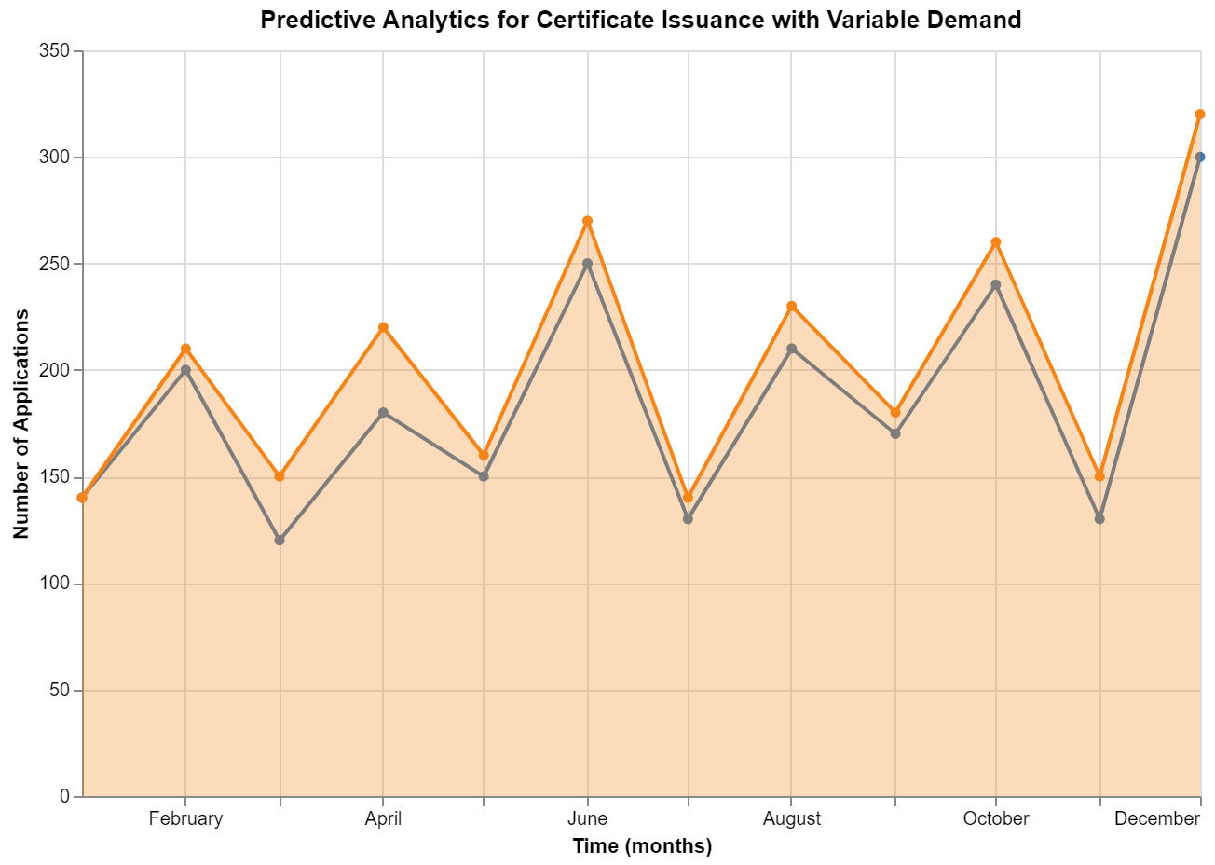
- Predictive Analytics Visualization
Fig. 1. that illustrates predictive analytics that allows forecasting of service demand patterns over time for an organization to proactively allocate resources and reduce backlogs by adjusting staff and resources ahead

Various Approaches

Data Standardization
Standardization of data applies the feature of developing a uniform and homogenous format across all the data sources. Improper standardization leads to maximum precision with minimal errors, offering smooth integration and aggregation with sharing and analysis between departments hence allowing transparency in service and improving decision-making. Structures like JSON Schema and REST APIs provide structures for data exchange and therefore can communicate freely between other systems and conform to law regulations, which gains public confidence.

System Integration
System integration in public administration streamlines operations by having communication between different departments and their systems, ensuring effective flow of data and the resulting services. Standardizing of data formats and making an interoperable platform break all existing silos, hence availing real-time information among those different departments through one core system. This inter-connected mode is supportive of even services such as certificate issuance which should cross-reference data from multiple sources such as identity verification and residence records. Integrated systems improve speed and accuracy by removing redundancy and minimizing the amounts of manual data entry because information flows smoothly from one department to another. Moreover, integrating systems improves decision-making for administrators because they are in a position to access detailed up-to-date information along all spheres of relevance thereby facilitating a harmonized approach to resources allocation and policy implementation. This holistic connectivity helps theoperation of public services to run smooth and provide citizens with fast, reliable services, thus having a more responsive framework.

Real-Time Monitoring
Public administration needs monitoring as a response mechanism to changing demands in services and making resource allocation better. Application volume, processing
time, and imbalances in regional demands can be constantly monitored to influence reactions among administrators. For instance, in the case of an unexpected increase in application in a given region, administrators will be in a position to re-allocate resources in regions with fewer applications so service delivery is not slowed. Finally, real-time monitoring promotes transparency whereby departments can make performance metrics such as response times and resource utilization open to review to create accountability and improve citizens' confidence. This will change public administration from being a static resource model to a dynamic, data-informed organization that can respond resiliently to variable demand in efficient ways-a recipe for delivering better-quality public services and greater citizen satisfaction.

- Key Tehnologies in Public Administration Resource Allocation and Monitoring:

Technology | Description | Evidence Source | Specific Feature
Predictive analytics | forecasts demand using historical data, allowing for proactive resource allocation. | Ullah et al [14] | Models like ARIMA, LSTM; demand trend forecasting
Cloud computing | permits centralized, scalable data access and storage, allowing for real-time modifications. | Nabawy, et al [15] | Centralized data, cloud-based scalability, real-time data access
Machine learning | Based on projected needs, AI models optimize resource allocation and forecast service demand. | Zhang [16] | Algorithms for trend analysis, clustering (e.g., K-means), time series forecasting
System Integration | improves collaborative resource management by connecting different departmental data systems. | Wu et al [17] | Data sharing standards, REST APIs, JSON format for data exchange
Table I is describes, identifies predictive analytics, cloud computing, machine learning, and system integration as core technologies, each enabling demand forecasting, centralized data access, and cross-departmental resource managemen

Analysis of Existing Solutions
The current solutions available in public administration are resource allocation models that rely more on static allocation, where the resources depend on historical data allocation instead of real-time demands [18]. Such models fail to meet the dynamic requirements of high-demand areas, such as certificate issuance, since demand is always fluctuating. Solutions involving real-time data processing, predictive analytics, and adaptive resource allocation have been successful in managing variable demand in sectors like healthcare and emergency services. Such sectors utilize centralized cloud platforms and AI-based analytics to predict demand and allocate resources efficiently, making this a model that would also be important if adapted to public administration.
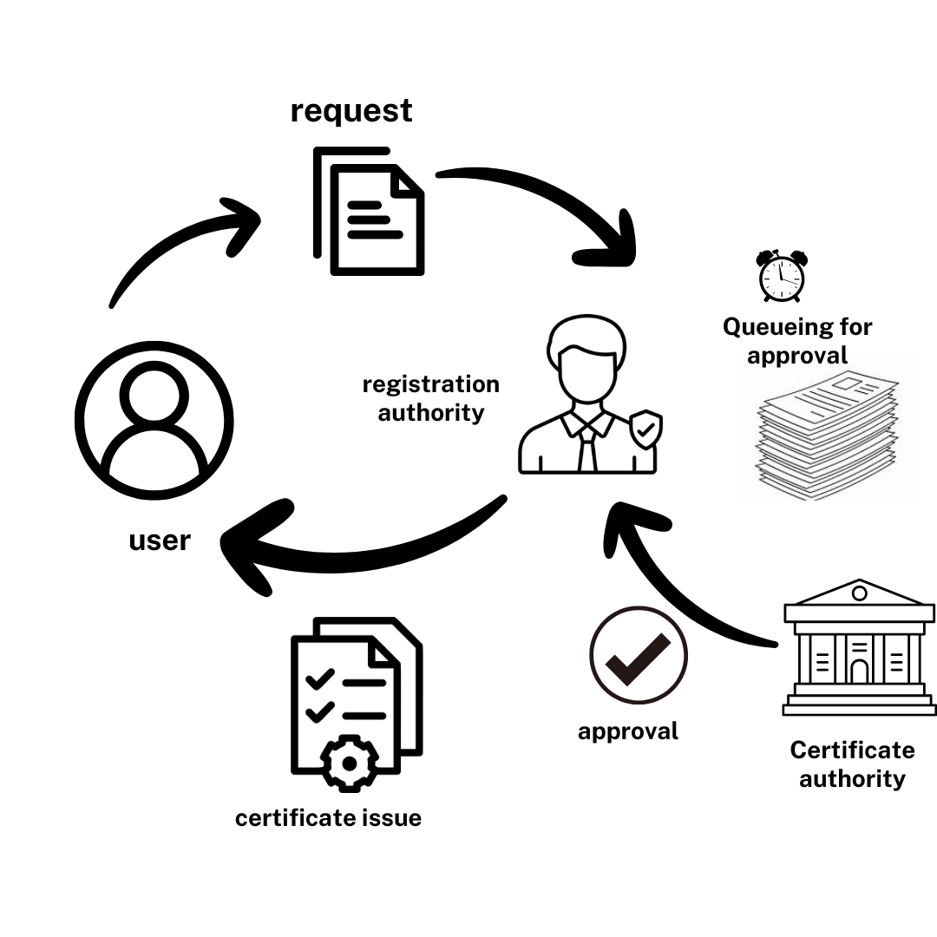
- Traditional Resource Allocation Process
Fig. 2. illustrates the traditional public administration static resource allocation model. Here, the old-fashioned fixed method of allocations in which allocations are carried once without regard to the fluctuations as dictated by either accommodation or demand is portrayed.
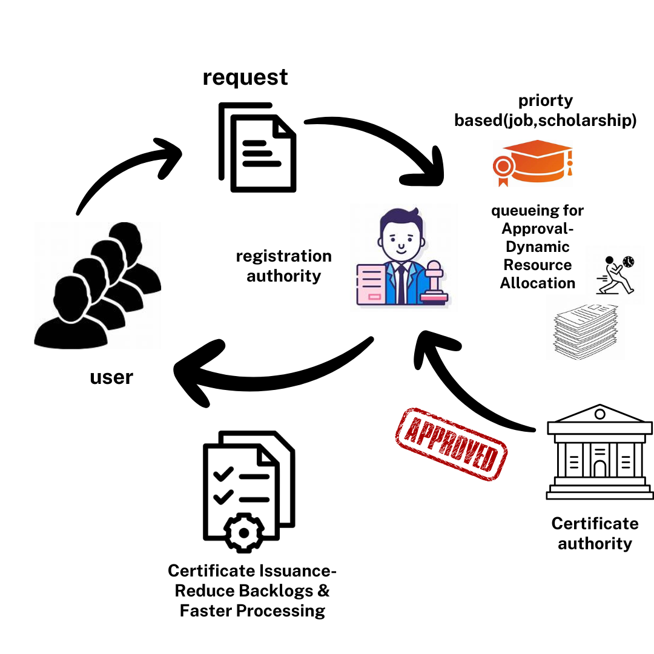
- Optimized Resource Allocation Process

Fig. 3. depicts an optimized resource allocation process with real-time adjustments based on data insights. It contrasts the traditional model in that it supports dynamic demand change responses and thus optimizes service delivery overall.

Analysis of Current Approaches and their End
The contemporary approaches in public administration suffer from limitations as they depend more on rigid and nonadaptive models that fail to be flexible. Resource allocation models tend to lack adaptability towards real-time changes in demand and, at times, create bottlenecks and backlogs. Most such models work in silos to avoid the sharing of comprehensive data across departments and almost by default limit the scope for collaborative resource management. While most sectors have adapted successfully with real-time monitoring and predictive analytics, public administration often lags, and problems ranging from infrastructure relics, to regulatory regulation, to financial constraints will weigh against it.

Challenges and Limitations
There are mainly three limitations: Interoperability among departments is pretty low, reliance on old legacy systems is very high, and real-time integration of data does not exist [19]. This hinders the ability to respond in a timely manner to demand volatility. Issues involving privacy and security further complicate data sharing to this extent, given that most public sector data is highly regulated. Budget also appears to be a limitation: such cloud infrastructure and predictive technologies are very capital-intensive. Change resistance within the classic administrative bodies may also impede and slow the development of adaptive, technology-based solutions in public administration.

Success Factors
Numerous factors determine success in real-time resource allocation systems in public administration. First of all, there must be a central cloud infrastructure that is available and offers storage space as well as provides the possibility of real-time online access for various departments. Predictive analytics and machine learning models are also quite important, as they can predict trends in the demand for the distributions system to make necessary allocations in advance. Interoperability between departments and data standardization depend on effective cross-departmental collaboration. Transparency and accountability are ingrained in the application, so the features of integration showing resource allocation to citizens and service performance should be critical.

Best Practices
The best practices in public administration to optimize resource allocation are standard data protocols such as JSON Schema and API frameworks that enable interoperability. Using predictive analytics models like ARIMA or LSTM helps track demand and make proactive resource management. Real-time monitoring of increasing demand triggers for administrators using centralized dashboards and automatic alert systems would improve the quality of services. Operations are further optimized through cloud infrastructure to improve scalability and automation tools for the routine performance of tasks. Public administration transformation would be guided by best practices from sectors such as healthcare, where adaptive frameworks had been well applied.

Proposed Framework

Conceptual Model
The conceptual model for the framework proposed in public administration will be the data-driven optimization approach to the allocation and the efficiency of resources and services. Integral features of the multi-layered framework include real-time monitoring, predictive analytics, and system integration. With such a framework, departments will find it possible to good predict and alter demand through this dynamic resource management approach. A new framework that strives for efficient applications processing-even at busy times-in high-demand areas must deliver instant insight into decision-making processes data-driven framework for resource allocation. Layers include data collection, predictive analytics, real-time monitoring, and decision support, reflecting, at each step, a smooth, streamlined process in dealing with fluctuating demands for services.

Testing and Automation
Testing and automation are an essential constituent of a reliable and scalable framework. Automated Testing tools validate every component-from ingesting data to predictive accuracy-with load testing ensuring that the system scales up at times of peak performance]. Real-time monitoring tools track performance metrics for the systems involved, and automated alerts notify administrators about anomalies that can ensure an always-responsive and stable environment that only minimizes downtime while supporting uninterrupted public service delivery.
- Evaluation Metrics
No. | Metric | Description | Source
1 | Processing Time | analyzes how long it takes to issue documents and process requests. | Celik., et al [20]
2 | Resource Utilization Rate | checks how well resources are being used in regions with high demand. | Cassman et al [21]
3 | Citizen Satisfaction | evaluates how satisfied the public is with service quality and response time. | Romero-subia et al [22]
4 | Demand Forecast Accuracy | measures the accuracy of demand change prediction models. | Fiig et al [23]
5 | Cost Efficiency | Analyzes cost savings from optimized resource allocation and technology integration. | Kumari, s. [24]

Table II describes, specifies performance indicators—processing time, resource usage, citizen satisfaction, and forecast accuracy—to measure the impact of real-time data and adaptive resource management on service delivery.

Real-Time Monitoring Framework
The Real-Time Monitoring framework on certificate issuance would collate the data collected from application counters, online portals, and feedback systems all into one central dashboard and thus enable smooth decision making. Data Collection Layer Fetches real-time data from counters of applications, online portals, and feedback systems in terms of submission times, uploads, and user satisfaction. Data Integration Layer work is Processes and standardizes data for uniformity while storing it in a scalable database for easy access and analysis. Monitoring Layer: Visual tools like Grafana, Power BI, to display dashboards with KPIs like processing time. Anomalies alert for delays or spikes. Resource Allocation Layer Used to predictive analytics to dynamically allocate resources, manage demand, and scale capacity automatically. Transparency Layer is Tracks processing times and application status while ensuring security, privacy, and traceability with role-based access controls.

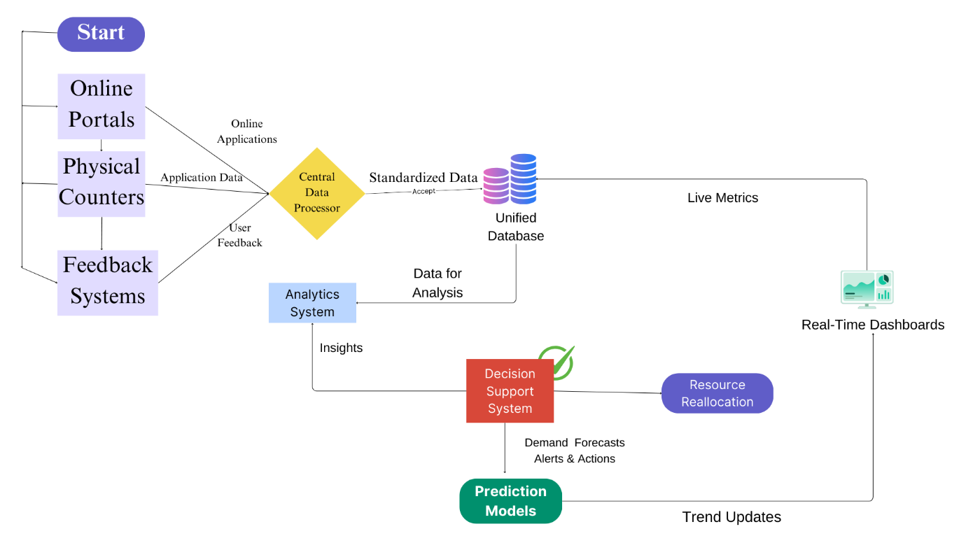
- Data Flow Diagram for System Integration
Fig. 4. represents a data flow diagram of how real-time data integration from sources distributed over some areas, including application counters, and portals feed into a centralized dashboard to support monitoring, analysis, and hence proactive resource management and decision-making.

Discussion

Theoretical Implications:
This review and framework enrich public administration literature with a structured, data-driven approach to resource allocation, which integrates real-time monitoring, predictive analytics, and system integration. It advances the adaptive resource management of the public sector from static towards technology-led models. A paradigm shifts from reactive towards proactive service management will therefore be seen in it-by bridging theoretical models towards AI-driven operational solutions-by providing AI and machine learning as predictive insights.

Practical Results:
Actionable insights are forwarded to allow practitioners to access technology for decision support as well as service improvement in areas of resource allocation. Advanced preparations in predictive analytics prior to the occurrence of any bottlenecks will ensure uninterrupted service delivery quality. System integration brings interdisciplinary cooperation thereby eliminating duplication in the process while promoting improvement in decision-making for efficient, responsive, transparent and accountable service delivery.

Future Research Directions
Future work should be focused on developing sophisticated predictive models ways tailored to specific demands of the public sector and consideration of regulatory constraints or variance in service patterns. The opportunities for research could be expanded further to include AI-driven decision systems that can automatically manage changes in resources, making services they are providing adaptive without necessitating substantial manual oversight [108]. Further investigation into cross-departmental data integration frameworks should also be conducted to enhance interoperability across government agencies, which would ease flows of data further to enable more coordinated resource allocation

Conclusion

Summary of Findings
Resource Management Framework:
Augmented Efficiency: Real time monitoring, predictive analytics and systems integration will help in not just reactive but proactive resource management
Proactive Resource Allocation: Such a framework claims to enable the departments predict the demanding patterns and thus allocate resources dynamically
Technology Integration: Cloud computing, AI and standardized data sharing protocols are some of the key elements that cut down on public administration delays and increase transparency
Citizen Satisfaction: Increased transparency, with improved service efficiency should give a fillip to citizen satisfaction.
Agile and Resource-Effective Utilization: The data-driven framework is agile by nature, which aims at the elimination of bottlenecks and the maximization of operational efficiency.

Recommendations
All these can contribute to efficiency and interoperability among offices and departments with cloud-based platform investment, AI capability building, and data infrastructure upgradations. The employees and administrators are required to be trained to understand how the concept of operations works through data, and hence how to deploy real-time monitoring and prediction tools. Proper, rigorous measures for privacy and security will be needed to establish public trust in such sensitive information. Together, they would each contribute to a more responsive, accountable, and transparent resource management system better to serve citizens.
Data Availability:
The data used to support the findings of the study are included in the article. Should further data or information we require this are available from corresponding author upon request.

References

- Singh, I. (2024). Reinventing Public Service Delivery: A Case of Delhi.
- Mihai, S., Yaqoob, M., Hung, D. V., Davis, W., Towakel, P., Raza, M., ... & Nguyen, H. X. (2022). Digital twins: A survey on enabling technologies, challenges, trends and future prospects. IEEE Communications Surveys & Tutorials, 24(4), 2255-2291.
- Akuche, C. C., & Akindoyin, D. I. (2024). Elucidating the Problems of Service Delivery in the Nigerian Local Government System since the Fourth Republic. Kashere Journal of Politics and International Relations, 2(2), 396-406.
- Ibrahim, M. (2024). Unleashing the Potential of Artificial Intelligence for Dynamic Supply Chain Optimization and Sustainability. In Navigating the Circular Age of a Sustainable Digital Revolution (pp. 381-410). IGI Global.
- Vithal, C. P. (2004). Some Crucial Issues and Challenges of Governance. Indian Journal of Public Administration, 50(4), 1025-1045
- Alsadie, D. (2024). A Comprehensive Review of AI Techniques for Resource Management in Fog Computing: Trends, Challenges and Future Directions. IEEE Access.
- Υφαντής, Β. (2024). Cutting-edge computational systems and emerging technologies applied to e-government and virtual environments.
- Kulal, A., Rahiman, H. U., Suvarna, H., Abhishek, N., & Dinesh, S. (2024). Enhancing public service delivery efficiency: Exploring the impact of AI. Journal of Open Innovation: Technology, Market, and Complexity, 10(3), 100329.
- Rane, J., Kaya, O., Mallick, S. K., & Rane, N. L. (2024). Influence of digitalization on business and management: A review on artificial intelligence, blockchain, big data analytics, cloud computing, and internet of things. Generative Artificial Intelligence in Agriculture, Education, and Business, 1-26.
- Mitropoulou, K., Kokkinos, P., Soumplis, P., & Varvarigos, E. (2024). Anomaly detection in cloud computing using knowledge graph embedding and machine learning mechanisms. Journal of Grid Computing, 22(1), 6.
- Ganjouhaghighi, N. (2024). Improving Emergency Department Efficiency: A Study of Physician Scheduling Strategies to Reduce Patient Wait Times.
- Ezeugwa, F. A. (2024). Evaluating the integration of edge computing and serverless architectures for Enhancing Scalability and Sustainability in Cloud-based Big Data Management. Journal of Engineering Research and Reports, 26(7), 347-365.
- Trianasari, N., & Permadi, T. A. (2024). Analysis Of Product Recommendation Models at Each Fixed Broadband Sales Location Using K-Means, DBSCAN, Hierarchical Clustering, SVM, RF, and ANN. Journal of Applied Data Sciences, 5(2), 636-652.
- Ullah, I., Raza, B., Malik, A. K., Imran, M., Islam, S. U., & Kim, S. W. (2019). A churn prediction model using random forest: analysis of machine learning techniques for churn prediction and factor identification in telecom sector. IEEE access, 7, 60134-60149.
- Nabawy, R. M., Hassan-Ibrahim, M., & Rabee-Kaseb, M. (2024). Survey of Mobile Cloud Computing Security and Privacy Issues in Healthcare. Computación y Sistemas, 28(3).
- Zhu, X., Zhang, G., & Sun, B. (2019). A comprehensive literature review of the demand forecasting methods of emergency resources from the perspective of artificial intelligence. Natural Hazards, 97, 65-82.
- Wu, C. H., Chiu, R. K., & Yeh, H. M. (2017). Implementation of a cloud-based electronic medical record exchange system in compliance with the integrating healthcare enterprise’s cross-enterprise document sharing integration profile. International Journal of Medical Informatics, 107, 30-39.
- Zhang, M., & Kaur, M. (2024). Toward a theory of e-government: Challenges and opportunities, a literature review. Journal of Infrastructure, Policy and Development, 8(10), 7707.
- Rosenkranz, S., Staegemann, D., Volk, M., & Turowski, K. (2024). Explaining the Business-Technological Age of Legacy Information Systems. IEEE Access.
- Celik, A., & Dogan, O. (2024). Optimization of travel requests with process simulation analysis. Computers & Industrial Engineering, 196, 110487.
- Cassman, K. G., Dobermann, A., Walters, D. T., & Yang, H. (2003). Meeting cereal demand while protecting natural resources and improving environmental quality. Annual Review of Environment and Resources, 28(1), 315-358.
- Romero-Subia, J. F., Jimber-del Rio, J. A., Ochoa-Rico, M. S., & Vergara-Romero, A. (2022). Analysis of citizen satisfaction in municipal services. Economies, 10(9), 225.
- Fiig, T., Härdling, R., Pölt, S., & Hopperstad, C. (2014). Demand forecasting and measuring forecast accuracy in general fare structures. Journal of Revenue and Pricing Management, 13, 413-439.
- Kumari, S. (2024). Cloud Transformation for Mobile Products: Leveraging AI to Automate Infrastructure Management, Scalability, and Cost Efficiency. Journal of Computational Intelligence and Robotics, 4(1), 130-151

